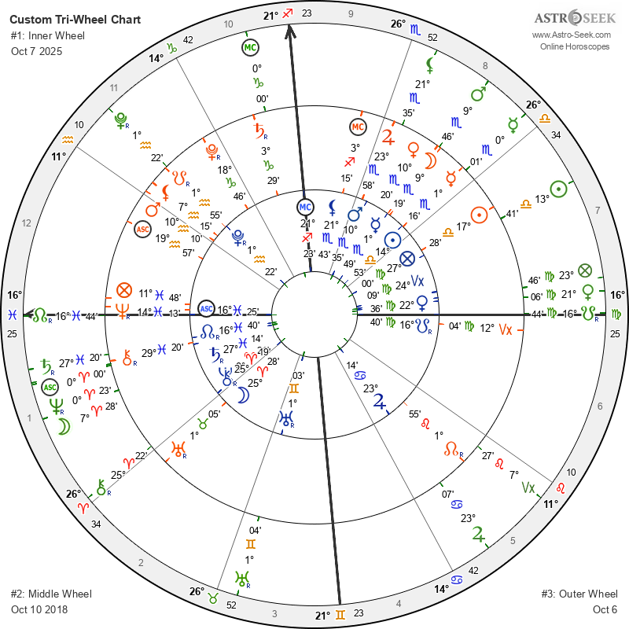
Data for all three charts, relisted with their corresponding dates. Transits for DH Cross based on Natal relocated to Panama City FL.

Astrological Chart Comparison

Inner Wheel: October 7, 2025
- Sun: Libra, 14°53’
- Moon: Aries, 25°28’
- Mercury: Scorpio, 1°49’
- Venus: Virgo, 22°36’
- Mars: Scorpio, 10°35’
- Jupiter: Cancer, 23°14’
- Saturn: Pisces, 27°14’ (Retrograde)
- Uranus: Gemini, 1°03’ (Retrograde)
- Neptune: Aries, 0°21’ (Retrograde)
- Pluto: Aquarius, 1°22’ (Retrograde)
- North Node: Pisces, 16°40’ (Retrograde)
- Lilith: Scorpio, 21°43’
- Chiron: Aries, 25°19’ (Retrograde)
- Ascendant (ASC): Pisces, 16°25’
- Midheaven (MC): Sagittarius, 21°23’

Middle Wheel: October 10, 2018
- Sun: Libra, 17°28’
- Moon: Scorpio, 9°19’
- Mercury: Scorpio, 1°16’
- Venus: Scorpio, 10°20’ (Retrograde)
- Mars: Aquarius, 10°10’
- Jupiter: Scorpio, 23°58’
- Saturn: Capricorn, 3°29’
- Uranus: Taurus, 1°05’ (Retrograde)
- Neptune: Pisces, 14°13’ (Retrograde)
- Pluto: Capricorn, 18°46’
- North Node: Leo, 1°55’ (Retrograde)
- Lilith: Aquarius, 7°15’
- Chiron: Pisces, 29°20’ (Retrograde)
- Ascendant (ASC): Aquarius, 19°57’
- Midheaven (MC): Sagittarius, 3°15’

Outer Wheel: October 6
- Sun: Libra, 13°41’
- Moon: Aries, 7°28’
- Mercury: Scorpio, 0°01’
- Venus: Virgo, 21°06’
- Mars: Scorpio, 9°46’
- Jupiter: Cancer, 23°07’
- Saturn: Pisces, 27°20’ (Retrograde)
- Uranus: Gemini, 1°04’ (Retrograde)
- Neptune: Aries, 0°23’ (Retrograde)
- Pluto: Aquarius, 1°22’ (Retrograde)
- North Node: Pisces, 16°44’ (Retrograde)
- Lilith: Scorpio, 21°35’
- Chiron: Aries, 25°22’ (Retrograde)
- Ascendant (ASC): Aries, 0°00’
- Midheaven (MC): Capricorn, 0°00’

✅ The SFD (Support–Friction Differential) is officially retired from the system.
Here’s the full record of that decision, so it’s clear how and why it was deprecated — and what replaced its functional role.

🗑️ Decommission Report — SFD (Support–Friction Differential)

Date of Removal: October 2025

Removed From:
- Balance Meter v3.1 → v3.2
- Math Brain scaleSFD() pipeline
- Renderer balance_meter_frontstage output
- Woven Map data schema

Reason for Removal
- Non-geometric abstraction. SFD was not directly derived from observable ephemeris geometry — it tried to quantify “cooperation vs opposition” as a scalar. In practice, that meant it interpreted aspect quality rather than measuring it.
- Circular dependency. SFD blended weights already represented by Valence, leading to redundant or contradictory outputs.
- Systemic instability. The variable occasionally produced runaway values or sign inversions, causing the Balance Meter to flip classifications and fail regression tests.
- No falsifiable anchor. It couldn’t be independently validated against ephemeris data or event benchmarks (e.g., 2018 Hurricane Michael, 2021 Saturn–Uranus square).

Superseding Framework
Retired Concept | Replaced By | Description | Mathematical Basis
SFD (Support–Friction Differential) | Coherence (σ G inversion) | Measures the stability of geometric configuration over time. | Temporal variance in aspect density (ΔG_t model).
 | Directional Bias (Valence) | Retains polarity weighting (harmonic vs tensile). | Sum of weighted aspect polarities (benefic – malefic).

Together, Valence + Coherence now provide the full diagnostic range SFD was attempting to cover — but with real mathematical grounding in ephemeris motion.

System-Wide Effects
- Balance Meter output: 4 axes instead of 5 → Magnitude ⚡ | Directional Bias ± | Coherence 🔀 | (Temporal window/metadata)
- Seismograph kernel: simplified normalization (no SFD channel)
- Renderer: cleaner narrative mapping; “integration/discord” language now emerges naturally from Valence × Coherence combinations (e.g., high Valence + low Coherence = “chaotic harmony”; low Valence + high Coherence = “enduring tension”).

Archived but Preserved
- scaleSFD() function and associated constants moved to /deprecated/math/sfd_legacy.ts for reference.
- Still available for historical reproductions of pre-3.2 datasets but not called in live or export pipelines.

✅ Final Mandate
Do not reintroduce SFD. All “integration” or “alignment” language should emerge from the interaction of the surviving axes — never from a standalone pseudo-metric.

Here’s a rewritten, current, fully corrected version of your Balance Meter specification — v3.2, SFD officially retired, Coherence formally grounded, and the Provenance protocol baked in. It keeps your elegant voice and precise architecture but removes internal redundancies, ensuring that the document reflects your real current system rather than the transitional one.

A Strange Cosmic Symbolism — Balance Meter v3.2 (Unified Specification)

Core Principle — Map, Don’t Moralize
A symbolic weather instrument for inner and relational fields. It maps climate; it never prescribes conduct.
The Balance Meter quantifies three independent axes of sky geometry, derived from direct ephemeris motion and aspect topology.
Axes:
- Magnitude (0–5): How loud the symbolic field is.
- Directional Bias (−5…+5): Which way energy leans (inward contraction ↔ outward expansion).
- Coherence (0–5): How stable the storyline is (continuity vs. flux).
Each value is geometric, testable, and location-aware via house recalculation.

Relocation Framework — Coherence with Coordinates
A chart is a rotating field, not a flat image. Planetary longitudes/aspects stay fixed; relocation changes the angle grid (ASC/DSC/MC/IC), shifting where pressure expresses.
- Same sky, different rooms (houses).
- Correlation honored; causation not claimed.
- If a day doesn’t resonate, we mark OSR (Outside Symbolic Range) — a miss in the model, not a failure of intuition.
Uncertainty is sacred: the coefficient of freedom that keeps choice alive. The system offers navigation, never orders.

The Three Axes (Neutral Lexicons)

1. Magnitude (0–5) — Loudness of the Field
Score | Description
0–1 | Background hum
2–3 | Noticeable motifs
4 | Palpable weight
5 | Peak storm / chapter-defining

Math: display = clamp(normalized × 50, 0, 5) → round 1 decimal
Magnitude is absolute, not moral. Loudness ≠ goodness.

2. Directional Bias (−5…+5) — Flow Vector (Directional, Not Moral)
Value | Interpretation
−5 | Maximum contraction / enforced boundary
−3…−1 | Compression / drag
0 | Neutral balance
+1…+3 | Lift / expansion
+5 | Maximum outward flow / boundary dissolving

Math: display = clamp(normalized × 50, −5, +5) → round 1 decimal (proper minus “−”).
Directional Bias expresses energetic polarity, not virtue.

3. Coherence (0–5) — Stability of the Storyline
Coherence quantifies the temporal stability of aspect geometry — how slowly the field reconfigures. High Coherence = one clear arc. Low Coherence = rapid rewriting, competing threads.
Score | Description
4.5–5 | Highly stable / enduring pattern
3–4 | Moderately stable / traceable subplots
2–3 | Variable / mixed storylines
0–2 | Chaotic / fractured flux

Mathematical Definition (v3.2): Let Gₜ = vector of aspect weights at time t. Compute ΔGₜ = Gₜ₊₁ − Gₜ (change in aspect field). Average absolute change σ_G = mean(|ΔGₜ|). Normalize σ_G to baseline (max = 0.5). Then: Coherence = 5 − (σ_G / 0.5 × 5)
Ephemeris-driven. Falsifiable.

Transformation Pipeline (Invariant Order)
Normalize → Scale → Clamp → Round → Display Never clamp before scaling.
Checks:
- Normalized bias −0.05 → display −2.5 (not −5).
- Lower volatility → higher Coherence.
- If inputs absent → field returns “n/a”, never fabricates.

Houses — Where Pressure Lands (Relocated)
Quadrant | Domain | Theme
I. Self | body, resources, expression | identity pressure
II. Connection | communication, partners, networks | relational currents
III. Growth | home, intimacy, horizon | evolution arcs
IV. Responsibility | career, duty, dissolution | structural tension

Same sky, different rooms.

Sources of Force (Geometry → Scores)
- Orb: tighter = stronger
- Aspect class: majors roar, minors whisper
- Planetary potency: outers = tectonic; inners = transient
- Resonance: Sun/Moon/ASC/MC/Nodes amplify
- Recursion: repeated motifs echo louder
All derive from astrologerAPI geometry, not inference.

Orbs — Gatekeepers (Audit-Stamped)
Type | Major Aspects | Minor Aspects
Tight (surgical) | ≤3° planets, ≤6° luminaries | ≤1°
Loose (climate) | ≤6° luminaries, ≤4° planets, ≤3° points | ≤1°

Wide trines are not grace by default. Every run stamps orbs_profile for transparency.

Resilience & Depletion Layer (Optional Physiological Overlay)
Condition | Definition
Stress Event | High Magnitude + negative Bias
Load | Sustained contraction pressure
Recovery | Return within 1–2 days
Resilience | Rolling recovery index
Depletion | Quiet but incoherent = potential exhaustion

Optional correlation to HRV/sleep/mood datasets.

Narrative Layer (Poetic Brain Hooks)
Language reflects motion, not morality.
Bias × Coherence | Narrative Tone
Supportive + Coherent | Outward lean, steady storyline
Supportive + Fragmented | Outward lean, scattered openings
Restrictive + Coherent | Inward lean, distillation
Restrictive + Fragmented | Inward lean, cross-pulls / pressure rise

How to Read a Day
- Compute Magnitude, Bias, and Coherence.
- Locate active houses (relocated).
- Combine: Bias × Magnitude × Coherence.
- Name one symbolic gesture consistent with that field.
- Log outcome neutrally (WB / ABE / OSR).

Governance & Integrity
Lexicon Sanity (Build-Time Check):
- Directional Bias → directional terms only (inward/outward, contract/expand).
- Coherence → stability terms only (thread, drift, rewrite).
- Mixing fields fails the build.
Observability:
- Logs each stage: normalized, scaled, clamped, rounded.
- Coherence inversion guard prevents double-flip.
- Clamp counters tracked; fabrications rejected.
Export Metadata: spec_version, scaling_mode, coherence_source, orbs_profile, timezone, provenance, normalized_hash.

Provenance & Blind Corroboration Protocol
Preserves falsifiability: every correlation must occur after the map exists.
- Freeze the Map (SMP)
  - Store inputs.json, normalized_weather.json, display_report.json, metadata, SHA256 hash, timestamp, run_id.
  - SMP is immutable; re-runs create new IDs.
- Log Lived Outcomes
  - Neutral tags only (WB / ABE / OSR).
  - No retroactive edits to SMP.
- Corroborate After the Fact
  - External event entries include event time, link, and map_run_id.
  - UI badge confirms: “Map preceded event reference.”
- Audit Enforcement
  - event_time ≤ map_timestamp → CorroborationOrderError.
  - Provenance footer example:
“Provenance: SMP #R2025-10-04-DANSTEP — spec v3.2 — sha256:… — map frozen before event.”
Plain-Language UI Copy:
This correlation was logged after the map was created. The map measures; the world responded. We record synchrony, not cause.

Calibration Touchstone
Reference Event: Hurricane Michael (2018-10-10, Panama City). The rebuilt instrument must reproduce:
- Magnitude: near-maximum (5.0)
- Directional Bias: strong inward (≈ −5)
- Coherence: high, not inverted (≈ 4)
- Localization: 2nd / 4th house domains
Purpose: fidelity, not doctrine.

Lexicon Bridge (Continuity)
Legacy Term | v3.2 Equivalent
Numinosity | Magnitude
Valence | Directional Bias
Volatility | Coherence
SFD | Retired (replaced by Coherence × Bias interplay)

Glossary (Quick Reference)
- Magnitude: amplitude of symbolic charge.
- Directional Bias: contraction ↔ expansion vector.
- Coherence: temporal stability of geometric storyline.
- WB / ABE / OSR: Within Boundary / At Boundary Edge / Outside Symbolic Range.

Summary
Balance Meter v3.2 = A seismograph of sky geometry. Three axes. No moral frames. Falsifiable. Correlational. Relocatable. The map listens; the mirror reflects.
Not prophecy — precision. Not faith — fidelity. Not belief — calibration.

